Part C: Array Operations in C/C++
4. Write a C/C++ program to perform the following operations on arrays:

a) Traverse an array.
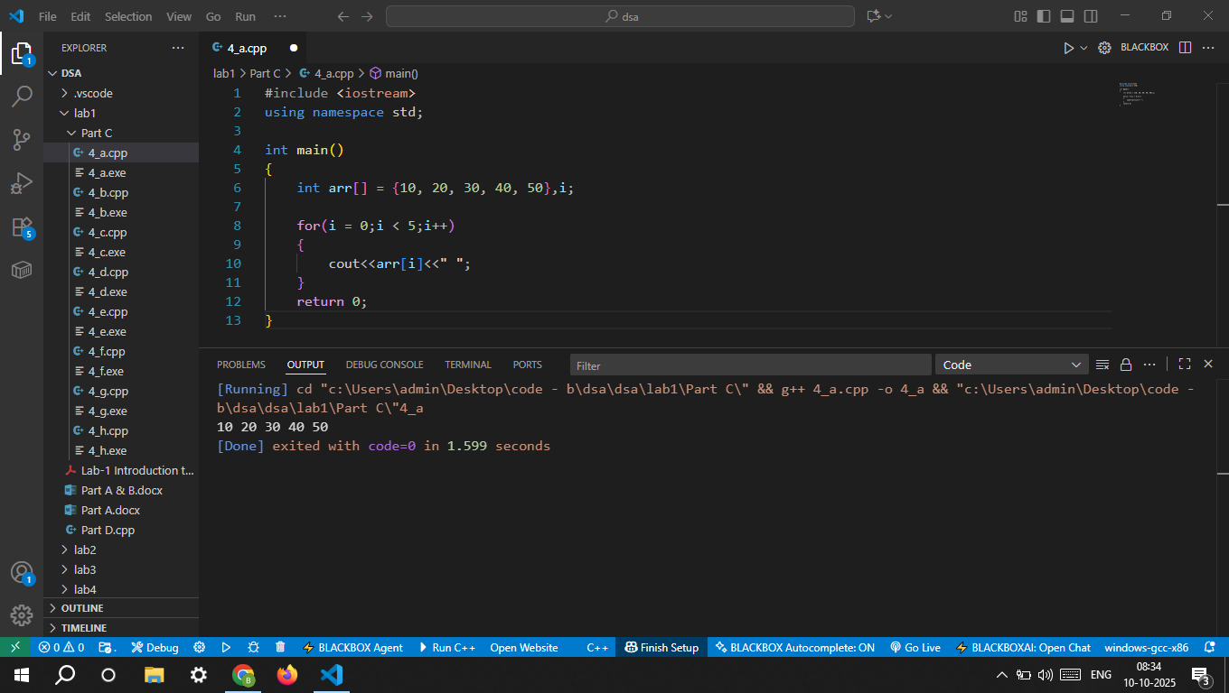

b) Find the number of element (Length) of an array
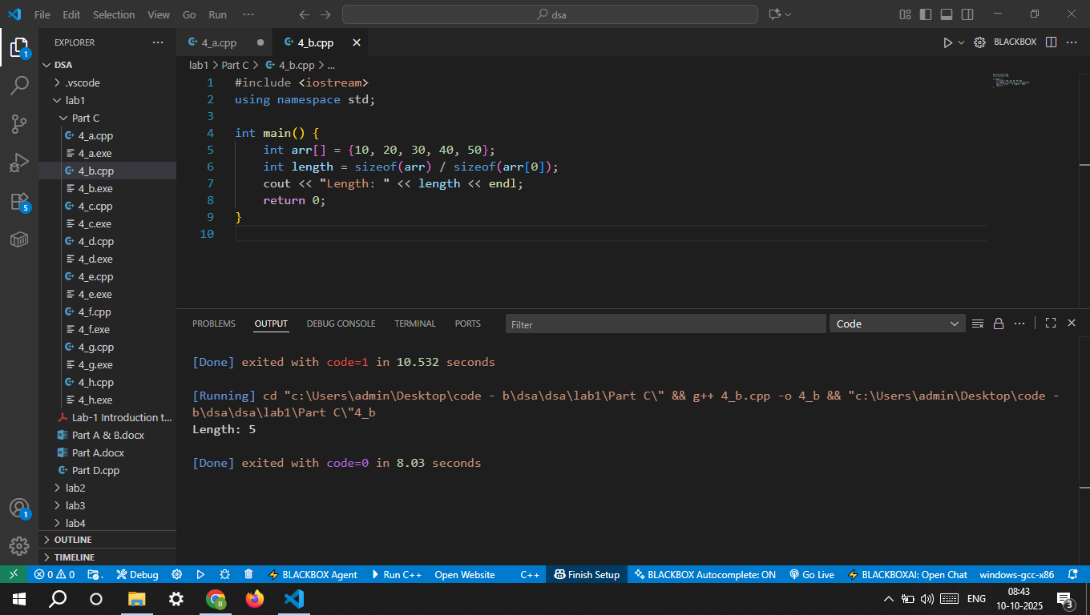

c) Search an element from the array. 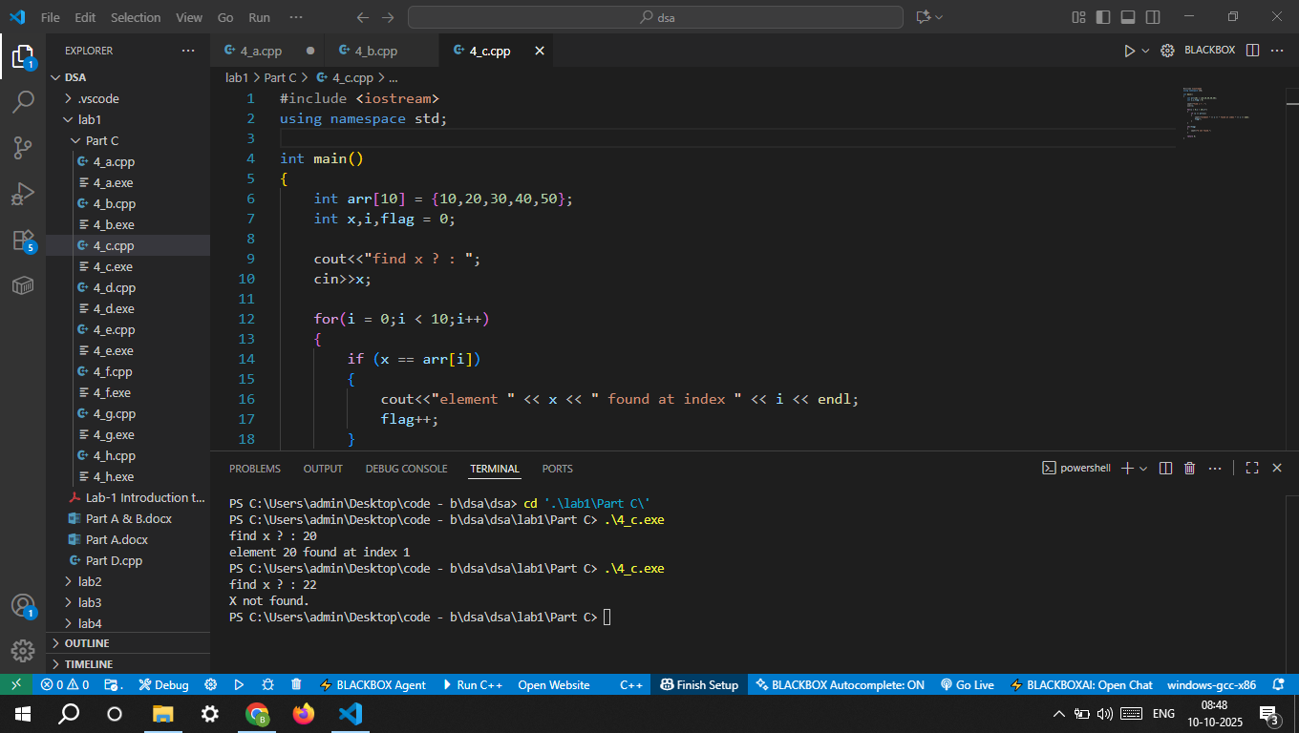

d) Find the largest element from the array.
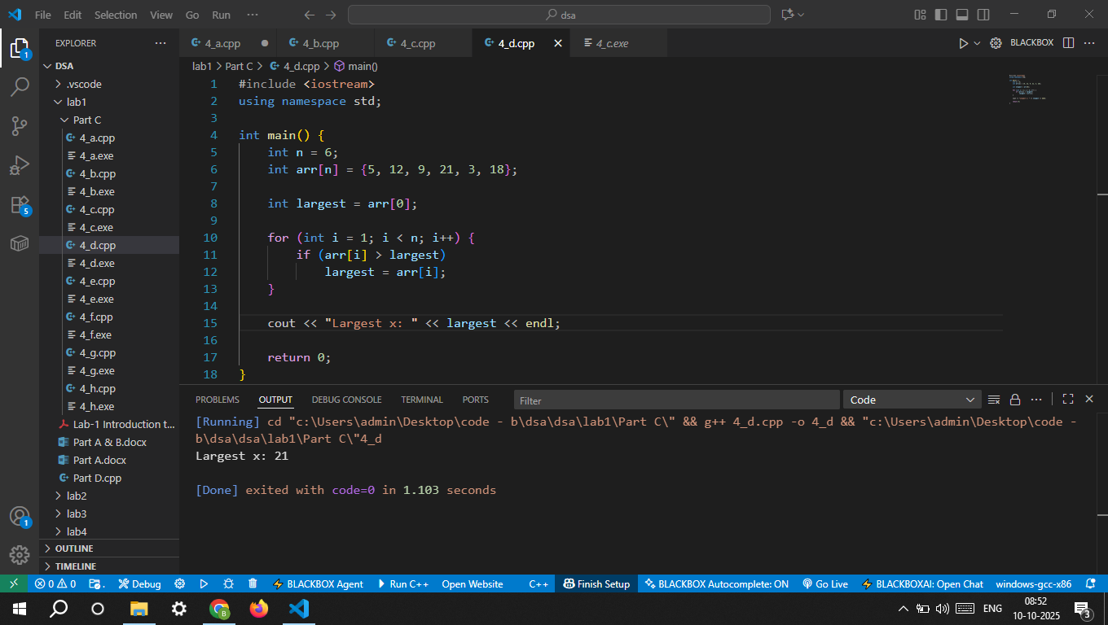

e) Find the smallest element from the array 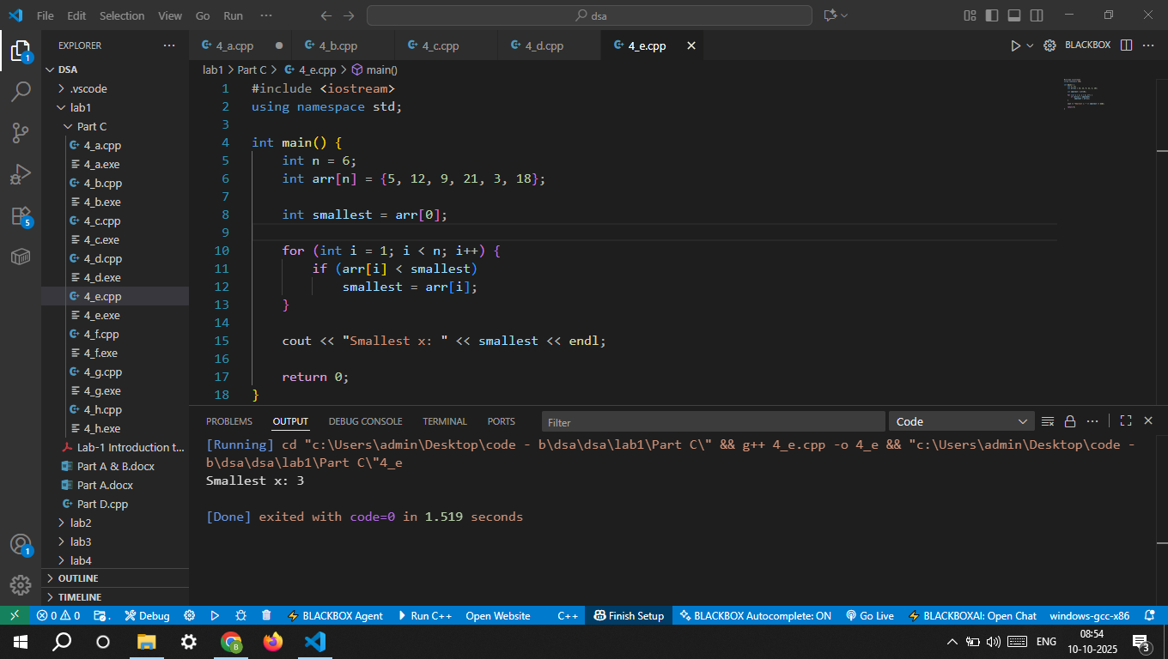

f) Insert an element at a given position in the array.
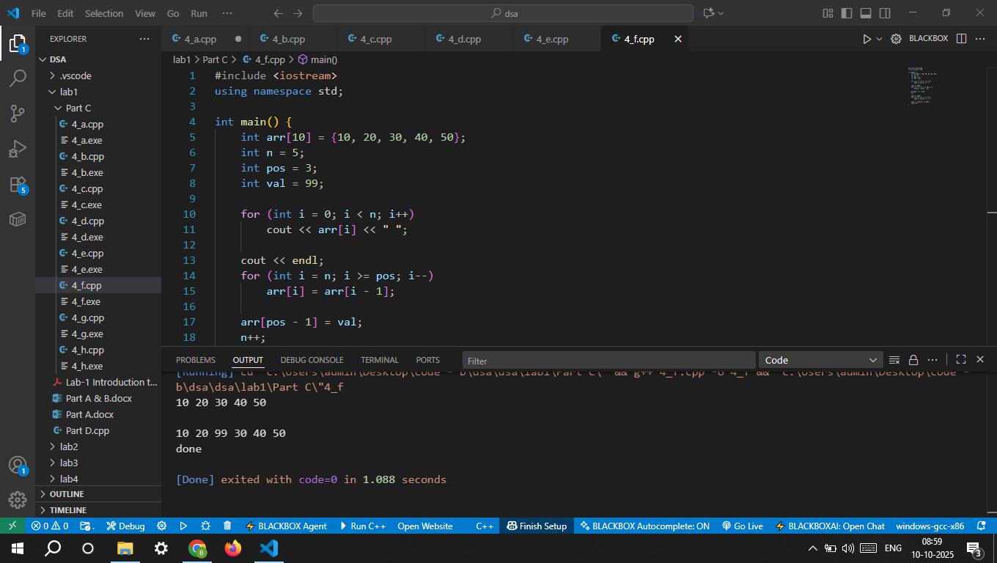

g) Delete an element from a given position in the array. 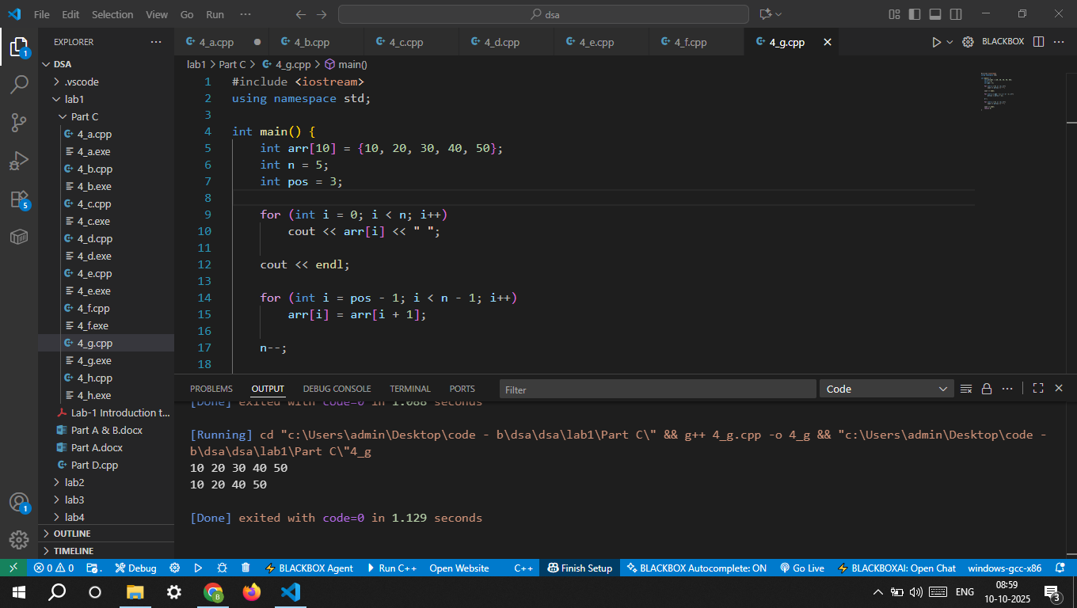

h) Search for an element using linear search.
